caCORE

Semantic Integration

Standard Operating Procedures
(SOP)

Last Modified:
May 4, 2006

The Semantic Integration Workbench (SIW) is designed to facilitate and streamline the process of semantic annotation — the steps whereby UML entities are mapped to EVS concept codes. This prepares the UML domain models for being loaded into the caDSR.
The semantic integration process using the SIW is illustrated in the following diagram, Figure 1a. Each part of the process, or Phase 1-5, depicted more clearly in the Detailed Overview, Figure 1b, and each Phase in subsequent sections.
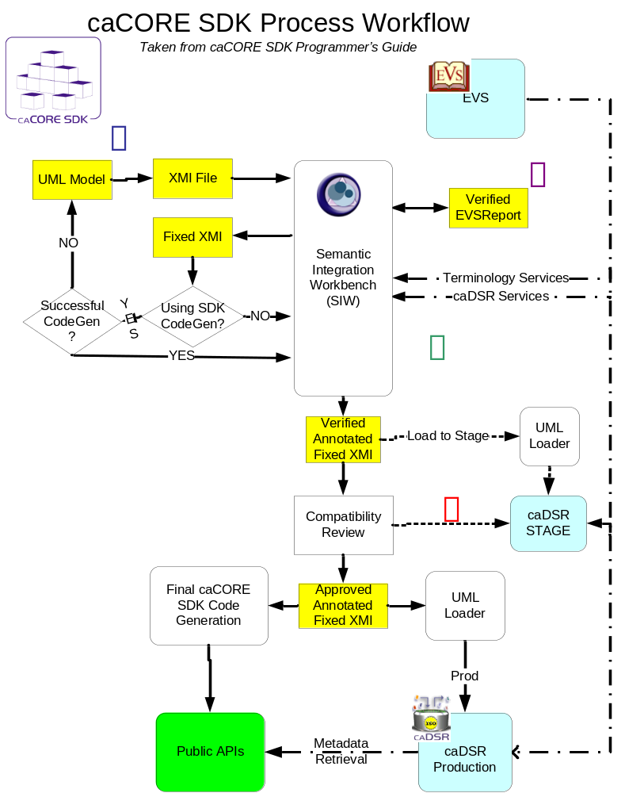
Figure 1a

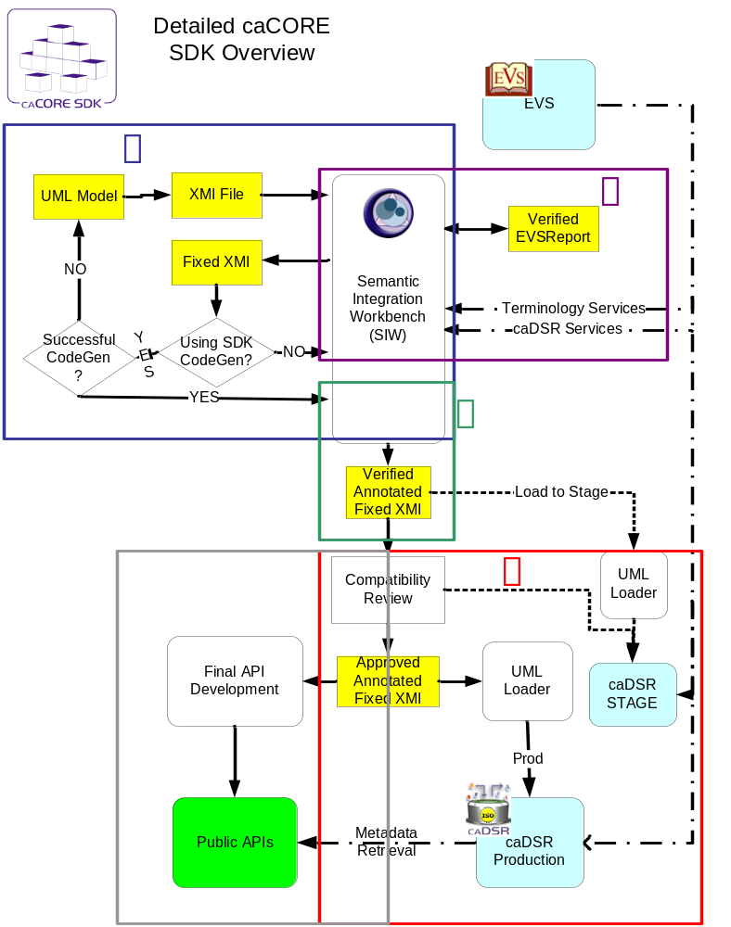
Figure 1b

The suggested workflow for using the SIW is displayed in the following four figures. An explanation of each figure follows detailing the Phases included in that figure.
Phase 1

In the first Phase of the process, the model owner creates an XMI file from the UML model and prepares it for submission to NCICB. In this Phase, SIW First Pass: Fix xmi is used and generates an EVS_Report.

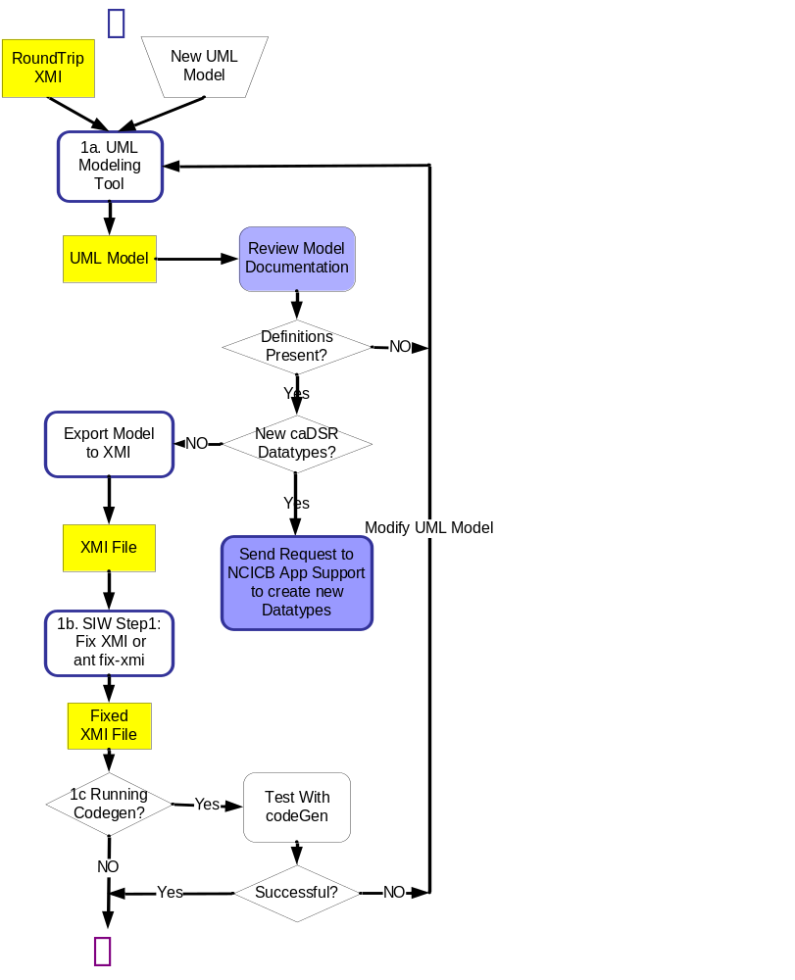
Figure 2
Phase 1
Phase 1 is divided into 3 sub-steps, which describe the process depicted in Figure 2. Nodes outlined in blue denote where the SIW is used; yellow nodes indicate that a file is produced or revised, blue nodes indicate documentation artifacts.
      - The model owner creates a new UML model or starts with an existing “Round Trip XMI” file. The Round Trip” XMI file is produced by running the SIW “RoundTrip” step which inserts existing caDSR content into an annotated fixed xmi file that was used to load the model. This step, “round Trip”, ensures that existing components are reused without the model owner having to repeat the concept mapping step.

Once the model owner has created a new model or modified a model using the “Round Trip” XMI, the model is exported XMI format. The caCORE SDK Programmers Guide provides best practice and guidelines for creating a UML model for loading to caDSR, such as how to name tagged values for model documentation, how to point to existing caDSR content and instructions for exporting a model in XMI format from a UML modeling program such as Enterprise Architect (EA).

The NCICB/caBIG UML Models project, gforge.nci.nih.gov/projects/registrymodels a Gforge site, provides access to all UML Model submission packages that have been requested to be loaded to caDSR. The “Files” section contains packages for each UML Model, th e”Tracker” section shows the current status of models being loaded, and the “Docs” tabl contains the latest copy of the Submission Template. The caCORE SDK Programmers Guide is located on the GForge site at http://gforge.nci.nih.gov/siw in the “Docs” section. To navigate to the guide, select the ‘Project Tree’ tab, select NCICB in the ‘Browse by’ list, select the caCORE project from the list, select ‘caCORE SDK’ on the Docs tab, select the version desired, then select “Documentation”.

The exported XMI from is named: {myModel}_v{X}_rv{X}.xmi where v{X} refers to Version X of the UML model and rv{X} refers to Revision X of that version.
For example: caBIO_v2_rv1.xmi refers to the second version, first revision of caBIO UML model.

Before proceeding to subsequent Phases that use the SIW, it is useful to create an RTF or MS Word version of the UML model. This aids in identifying any missing information that will be needed to complete semantic annotations, for example to verify that “documentation” (for class) and “description” (for attributes) tagged values are present and that all attributes have valid datatypes.

Step a:
Input: {myModel}_v{X}_rv{X}.eap
Output: {myModel}_v{X}_rv{X}.xmi
Documentation Output: {myModel}_v{X}_rv{X}.rtf or .doc
      - The model owner launches the SIW, then using the uml modeling tool generated XMI file from Step a. as input to the SIW Step 1: Fix xmi . Optionally, the model owner may run the Ant fix-xmi. Both processes execute the same fix-xmi script, whether the download version of the version executed by SIW. This step removes the modeling tool (EA) specific tags to facilitate the use standard XMI parsers.
The XMI output file name from this step is appended with the suffix “fixed” and is named: fixed_{myModel}_v{X}_rv{X}.xmi

Input: {myModel}_v{X}_rv{X}.xmi
Output: fixed_{myModel}_v{X}_rv{X}.xmi
For example: fixed_caBIO_v2_rv1.xmi

      - If the model owner is not running the codeGen program and is performing Semantic Annotations only, skip to Phase 2.

If the model owner is running the caCORE SDK codeGen program, codeGen must be tested before proceeding, using the file fixed_{myModel}_v{X}_rv{X}.xmi as input. If the file is able to be processed by codeGen test, and no modifications are required, proceed to semantic annotations Phase 2.

If the codeGen test is not successful, the model owner should iterate steps a and b makign changes to the model until a fixed_{myModel}_v{X}_rv{X}.xmi is produced that works with caCORE SDK codeGen. You may use the rtf file created in Step a. to aid in determining the source of errors.

- The model owner completes the Submission Template from the GFORGE UML Model Projects Docs section “UML Model Submissions”, and sends the template along with the designated files to the NCICB Apps Support group along with the model files and documentation. ncicb@pop.nci.nih.gov The NCI Apps Support group reviews the submission template.

If there are no issues, the process proceeds to Phase 2.

If items are missing or need revision in the Model, the NCICB Apps Support team contacts the Model Owner to ask them to make the necessary corrections.
Prior to running SIW Step 2, Semantic Connector First Pass in Phase 2, the following items must be verified
  - All entities have valid caDSR datatypes
  - All entities have documentation and description tags present for classes and attributes.

Phase 2

In this Phase, the names of entities (class, attribute) in the UML Model are mapped to concepts in the NCI Thesaurus (semantically annotated) by EVS staff in an iterative process, consulting with the model owner. Only concepts mapped to UML entities marked as “Human Reviewed” in the EVS Report are passed on to the Annotated XMI file. SIW Step 2: Semantic Connector First Pass (model owner), SIW Step 3: Curate Semantic Connector Report(EVS), SIW step 4: Semantic Connector Second Pass (model owner) are used to complete this phase.

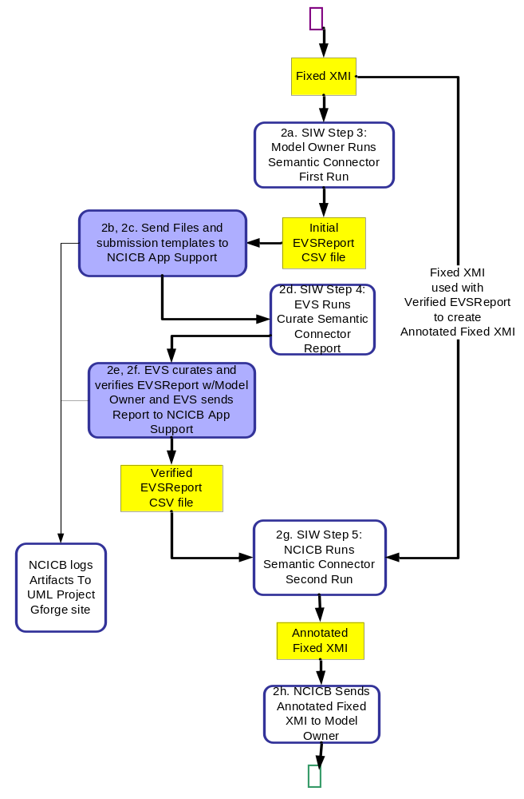
Figure 3
Phase 2
Phase 2 is divided into 6 sub-steps, which describe the process depicted in Figure 3. Nodes outlined in blue denote where the SIW is used; yellow nodes indicate that a file is produced or revised, blue nodes indicate non-tool assisted steps.

- The model owner runs SIW Step 2: Semantic Connector First Pass, which parses the XMI file and extracts the names of the UML entities that need to be semantically annotated, searches EVS NCIt for potentially matching concepts and creates a initial concept mapping report for review by EVS.

The output file from this step is appended with “EVSReport” in a CSV format and is named: EVSReport_fixed_{myModel}_v{X}_rv{X}.csv

Input: fixed_{myModel}_v{X}_rv{X}.xmi
Output: EVSReport_fixed_{myModel)_v{X}_rv{X}.csv

- The model owner fills out the active version of the UML Model Submission Template. The UML Model Submission Template is located on the GForge site at http://gforge.nci.nih.gov. To navigate to the template, select the ‘Project Tree’ tab, select NCICB in the ‘Browse by’ list, select caDSR in the NCICB list, select the hyperlink to ‘Semantic Integration Tools’, select the ‘Docs’ tab, select ‘UML Model Submissions’.

The model owner e-mails the UML Model Submission Template to NCICB Application Support (ncicb@pop.mail.nih.gov) with the subject line: “UML Model for EVS Curation” and includes a zip file of the following four attachments.:

- {myModel}_v{X}_rv{X}.eap
- fixed_{myModel}_v{X}_rv{X}.xmi
- EVSReport_fixed_{myModel}_v{X}_rv{X}.csv
- {myModel}_v{X}_rv{X}.rtf (documentation produced from EA before CodeGen)

Note: If the UML model was created using Enterprise Architect, the rtf documentation can be create using the documentation feature - See SDK Programmers Guide for detailed instruction on producing this documentation

- NCICB Application Support creates a Tracker item and logs all files received, along with the Submission Template into a folder created for the model in the “Files” section of the UML Model Project in the caDSR or caCORE folder.
- A GForge Task item is assigned to the EVS team and associated with the Tracker for the Project. This indicate that they should perform the next Phase in the process, SIW Step 3: Curate Semantic Connector Report.

- The EVS team, working with the model owner via email and phone conversations, reviews and modifies concept mappings in the file EVSReport_fixed_{myModel}_v{X}_rv{X}.csv and sets the Human Verified tag to “Y” for each UML entity as completed.
- The EVS team sends the verified EVSReport_fixed_{myModel}_v{X}_rv{X}.csv to NCICB Application Support who logs the CSV file into GForge.
- NCICB Application Support runs SIW Step 4: Semantic Connector Second Pass to produce a file called Annotated_fixed_{myModel}_v{X}_rv{X}.xmi, and logs it into GForge. Entities in the file EVSReport_fixed_{myModel}_v{X}_rv{X}.csv having a Human Verified tag set to “N” are not inserted into the Annotated XMI file; these are highlighted in the SIW Review Annotated Model as errors because they are missing concept mappings. A verified indicator is set to a default value of “N” in preparation for the review of the Annotated XMI file.

Phase 2 (Con’t)

Note: The Semantic Connector Second Pass uses the file fixed_{myModel}_v{X}_rv{X}.xmi as input and searches for a CXV file named EVSReport_fixed_{myModel}_v{X}_rv{X}.csv . SIW expects this file to be in the same directory path, with the same file name as the fixed XMI file but with an “EVSReport” prefix.

Input: fixed_{myModel}_v{X}_rv{X}.xmi looks for EVSReport_{myModel}_v{X}_rv{X}.csv
Output: Annotated_fixed_{myModel}_v{X}_rv{X}.xmi

- NCICB Application Support sends a copy of the file Annotated_fixed_{myModel}_v{X}_rv{X}.xmi to the model owner to perform SIW Step 5: Review Annotated Model.
Phase 3

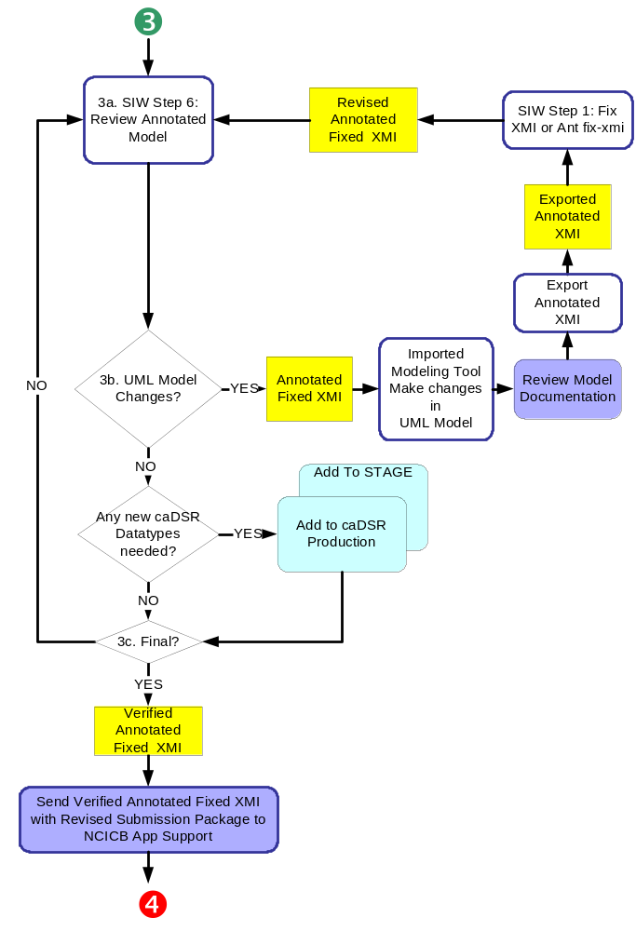In this Phase, the model owner reviews the annotated model and if accepted, the model is loaded to the caDSR Stage Server and submitted to VCDE for a Compatibility Review. SIW Step 5: Review Annotated Model is used.

Figure 4
Phase 3
Phase 3 is divided into 9 sub-steps, which describe the process depicted in Figure 4. Nodes outlined in blue denote where the SIW is used; yellow nodes indicate that a file is produced or revised. Blue nodes are documentation artifacts.

  - The model owner uses the SIW Step 5: Review Annotated Model to review and approve the concept mappings verified and recommended by EVS, as well as review associations and data types, and other validation information provided by SIW. All changes to the concept mappings at this point are made by the model owner in contact with the EVS staff who prepared the EVS Report file. As each UML entity review is competed, the model owner sets the Human Reviewed attribute to “Y”.
  - If changes are necessary in the UML Model to add documentation, associations, UML entity name changes, missing calsses, missing attributes, etc, the model owner must:
  - import the file Annotated_fixed_{myModel}_v{X}_rv{X}.xmi into a UML Modeling tool such as EA and make the necessary changes. Instructions for how to import the annotated XMI, see the caCORE SDK Programmers Guide.
  - produce new .rtf documentation to verify that no Documentation or Description tags are missing.
  - Re-export to XMI, using the export settings described in Phase 1a. The revision number must be incremented in the exported file name {myModel}_vX_rv(X+1).xmi. For example, caBIO_v1_rv2.xmi.
Note: It is recommended that the revision number be incremented for each iteration of changes for audit purposes.

- Rerun SIW Step 1: Fix xmi.
- Copy the last ‘verified’ version of the file EVSReport_{myModel}_v{X}_rv{X+1}.csv from Gforge in the UML Model Project>>Files folder for your project. Ensure the copied CSV file is renamed so that it matches the current revision number.

For example, if a new revision is named fixed_caBIO_v1_rv2.xmi then the EVSReport CSV file to be used with this iteration should be named EVSReport_caBIO_v1_rv2.csv

- Rerun SIW Step 4: Semantic Connector Second Pass
Input: fixed_{myModel}_v{x}_rv{x+1}.xmi
Output: Annotated_fixed_{myModel}_v{x}_rv{x+1}.xmi

Note: SIW automatically looks in the same specified directory for the fixed_{myModel}_v{x}_rv{x+1}.xmi file to attempt to locate the matching EVS report EVSReport__{myModel}_v{x}_rv{x+1}.csv

- Repeat Step 3a using the revised Annotated_fixed_{myModel}_v{X}_rv{X+1}.xmi using SIW Step 5: Review Annotated Model.

  - The model owner sends the final verified version of the Annotated_fixed_{myModel}_v{X}_rv{X}.xmi file to NCICB Application Support (ncicb@pop.mail.nih.gov) with a submission request to test loading the model to the caDSR Stage Server. If the model has been changed, the new EAP file, fixed_{myModel}_v{X}_rv{X+1}.xmi and documentation files should also be sent with the request to load the model to the caDSR Stage Server.
  - NCICB Application Support logs the final Annotated_fixed_{myModel}_v{X}_rv{X}.xmi file and associated documents (EAP and RTF) into GForge.

  - NCICB Application Support opens a GForge Tracker item to load the model to the caDSR Stage Server and assigns the item to the NCICB Content team.
Phase 4

Phase 4 is the last part of Semantic Annotation. Once the model has passed the VCDE compatibility review, the model owner issues a request to NCICB App Support to load the model to production and then completes model curation using caDSR web based tools.

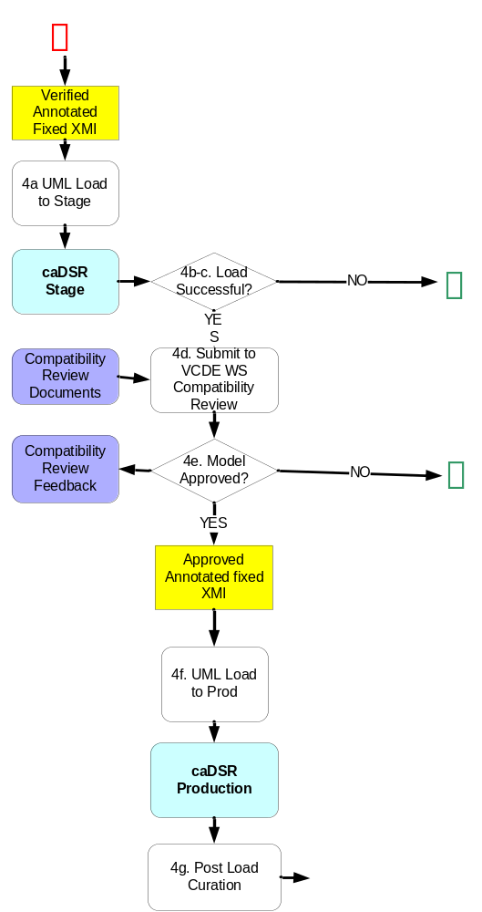

Figure 5

Phase 4
Phase 4 consists of 4 steps and includes running the model through the SDK code generator, if it is being used to create public APIs. This Phase is described in Figure 5.

  - The NCICB Content team runs the UML Loader and works iteratively with NCICB Application Support and the model owner until the model is successfully loaded to the caDSR Stage Server.

  - Notes: The UML Loader produces a log file of all items loaded to caDSR. This file should be logged into the GForge UML Model Projects files section for the model. Errors might include:

    - Errors in the Associations and/or Datatypes
    - Errors are fixed in the Annotated XMI file using SIW if possible – some may need to be fixed in the UML Model.
    - If changes are needed in the UML Model, Application Support documents the errors from the load into the Tracker item and requests new files from the model owner.
    - NCICB’s Application Support and Content teams work together to contact model owner to get changes to UML Model incorporated back through the semantic integration Phases 3a – d to produce a revised version of the Annotated XMI file, insuring to increment the revision number each time.

  - Each revision of the file Annotated_fixed_{myModel}_v{X}_rv{X}.xmi file must be loaded to the caDSR Stage Server until successful. Each time changes are made to the model, the revision number should be incremented by 1, …v1_rv2, v1_rv3, etc. This is an iterative process. The last file to load successfully to the caDSR Stage Server is used to load the model onto the caDSR Production Server.

NOTE: The model is not “moved” from Stage to Production. The Stage process ensures that the XMI file will load to Production and an opportunity for the model owner to view an approximation of how the model will appear once loaded to caDSR. Items that will differ between Stage and Production are the public IDs of the items loaded and potentially reused since new components are created in caDSR daily that may not be present on STAGE. The caDSR Stage Server is not a “mirror” of the Production Server; it is a copy created frequently, but not nightly.

  - Notify the caBIG VCDE Workspace Lead that you have a model for review. Complete the Silver Compatibility Package found on the UML Models Gforge project page in the Documentation section. (_________________) A caBIG VCDE Workspace Compatibility review is conducted using the caDSR Stage Server and compatibility review documentation to determine, among other items, if there are any major scientific concerns with the design or the vocabularies chosen for concept mapping.
  - Once the model is approved by VCDE, the model owner e-mails the approval to NCICB Application Support with a request to load the model to the caDSR Production Server. The specific version and revision number to be loaded should be included in the e-mail.
  - NCICB Application Support creates a Task to load the final version of the model onto the caDSR Production server. If procedures have been followed, the correct Annotated XMI file should already be in the GForge Files section for the model, as well as the Submission Template.

  - The model owner performs any needed post-load curation activities using the caDSR web based tools.

Phase 5
Phase 5 consists of the steps required to take the model through a ‘roundtrip’ step using SIW in which the naming and identification information for the caDSR items associated with the model are inserted into the XMI file. The model is then ready to put through codegen, if using SDK to generate public APIs, or other API development process. The last step is to validate that the APIs and registered metadata correlate. This Phase is described in Figure 6.

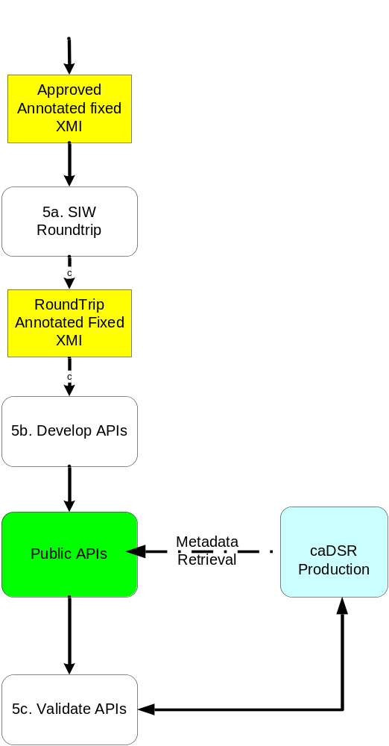

Figure 5

Phase 5

- Using the Annotated Fixed XMI file from Phase 4, the model owner uses the SIW to run the “Roundtrip” task. This task inserts caDSR naming and identification tags associated with the UML model class and attribute information.
- This step creates Public APIs to reach caBIG Silver Level Compatible. If the model owner is using the caCORE SDK to create Public APIs, the model owner uses the Annotated fixed XMI file that has been used to create caDSR metadata and logged into GForge with the SDK code generator to create the public APIs.

If the model owner is creating the APIs manually, the metadata in the Roundtrip Annotated Fixed XMI should be used as the basis for naming the API attributes and classes.
- Once the APIs are created, they should be validate to ensure that the data element names and characteristics match those exposed in the APIs.

Cross Functional Overview

Creating an accurate and correctly annotated semantic signature, registered in caDSR for UML Models involves a cross functional team, summarized in Figure 6 below.

The team is comprised of the following:

- UML Model Owner/Reviewer – design model, shepherd through the process, perform final cuartion
- NCICB EVS Team – initial concept review and creates new concepts
- NCICB Content Development Team – load the model to STAGE and PROD
- caBIG VCDE WS – conduct compatibility review

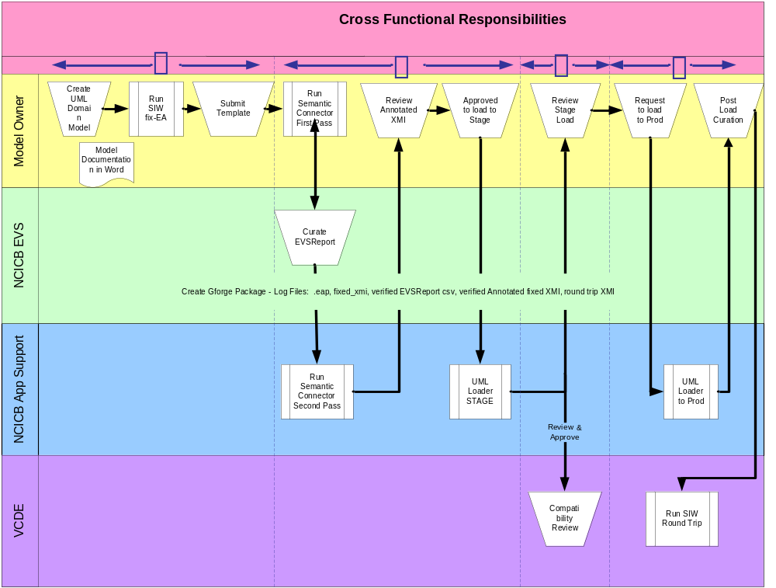
Figure 6

Definitions

EVS – Enterprise Vocabulary Services is the NCICB branch that creates the vocabularies that are made available to cancer researchers through web based browser, APIs and downloads.

SIW – Semantic Integration Workbench is part of the caCORE product line and provides the services in the Software Developers Toolkit for performing the annotation activities and validating the UML Model details to ensure that it convert correctly into caDSR ISO compliant metadata.

Semantic Integration – the process by which UML Model classes, attributes and associations are annotated using standard vocabulary concepts to convey the semantics of the UML entity.

Revision History
Revision | Date | Author | Change Reference | Reason for Change
0.1 | 2/22/2006 | Warzel | All figures | Make changes based on review feedback
0.2 | 3/13/2006 | Warzel | All Figures | Made changes based on SOP review
0.3 | 4/17/2006 | Warzel | Figure 6 | Corrected Load to production from NCICB EVS to NCICB App support
0.4 | 4/17/2006 | Warzel | Added definitions

